Weekly Bulletin – 12th May 2024 – Ascension Sunday

Thank you to Hon. Milton Dick, Federal MP, for generously printing our Bulletin.
We acknowledge and respect the Jagera people, traditional custodians of the land where our Parish resides.

12 May Ascension Sunday: Acts 1: 1-11; Psalm 93; Ephesians 1: 15-23; Mark 16: 15-20
19 May Pentecost: Acts 2: 1-21; Psalm 104:26-36; Romans 8:22-27; John 15: 26-27, 16:4b-15

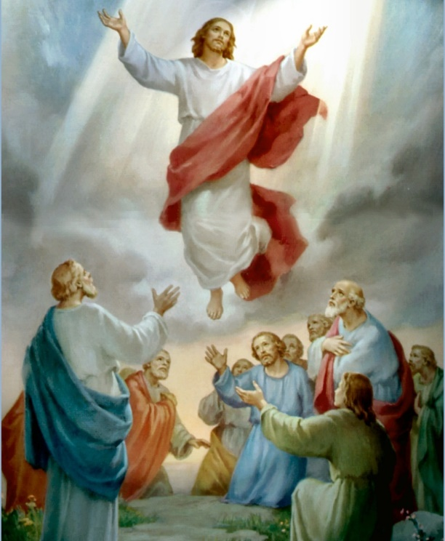
Sentence: Go into all the world and proclaim the good news to the whole creation,’ says the Lord. Mark16:15

Prayer of the Day
God of majesty,
you led the Messiah through suffering into risen life,
and took him up into the glory of heaven:
clothe us with the power promised from on high,
and send us forth to the ends of the earth
as heralds of repentance and witnesses of Jesus Christ,
the firstborn from the dead,
who lives with you now and always in the unity of the Holy Spirit,
God for ever and ever. Amen.

PSALM: Psalm 93 APBA p 321

DATES FOR YOUR DIARY & YOUR PRAYERS
Sunday 12 May 8.30 am Healing Ascension Eucharist & Sunday School followed by
Mothers’ Day High Tea at St Hugh’s
10.15 am Healing Ascension Eucharist at Forest Grove Auditorium
Tuesday 14th May 8.00 am Morning Prayer
9.00 am Careforce
3.00 pm Service at Opal Oxley Grove Aged Care
Wednesday 15th 9.00 am Eucharist at St Hugh’s followed by Morning Tea
Friday 17th 6.30 pm AMS in St Hugh’s Church Hall
Pentecost 19 May 8.30 am Eucharist at St Hugh’s & Sunday School
10.15 am Eucharist at Forest Grove Auditorium.

NOTICES:
**ITEMS needed for CAREFORCE: Large and small tuna tins, kids lunches, tinned meat, and baby nappies size 3 & 4. A huge thank you to all for your continued generosity**

*Women’s Fellowship Group meeting 1st Saturday of the month at 10am in the hall. All women are welcome. Contact Iris (0418 407 626) or Anne (0409 728 847) for more information.

*A.M.S. (Anglican Men’s Society) meet on the 3rd Friday of the month at 6.30 pm. All men are welcome. Contact Fr Lindsay, Neil, Geoff, Steve, or David for more information.

*Our next Bible Study will be on Peters First Letter. To commence first week after Pentecost. Please advise on list at the back of the church if you are interested. Cost is $5.00.

*For your diaries: We will be looking for expressions of interest for those interested in attending a three-day conference for those Anglicans seeking more Holy Spirit filled direction and encouragement. Dates currently set for 19th to 21st July. Please watch this space.

*At Sunday School we follow the Seasons of the Spirit curriculum. We nurture faith through liturgy, ritual, imagination, and encourage Christian growth through worshipping, learning, and serving together. Please email neil.holm.sthughs@gmail.com or text 0420936190 for more information.
This Photo by Unknown Author is licensed under CC BY-NC-ND

*The Portofino Fashion Show will be held at the Aveo Forest Grove Auditorium on Wednesday 22 May. Doors open at 9 am. Entry $5. All Welcome.

+ Contact Neil 0420 936 190 or Viv 0401884505 for our Prayer Ministry. +

Reflection for Ascension
______________________________________________________________________________________________
Jonathan Brook – Priest in Charge.
Please contact the office for Baptisms, Weddings, Funerals, and other pastoral matters.

